DSA J Component

Project – Initial Description

**TEAM MEMBERS:**

**ARYAMAN MISRA –19BCE1027**

**CLIVIN JOHN GEJU – 19BCE1480**

**HARSHANTH K PRAKASH- 19BCE1293**

**ARJUN SUNIL NAIR – 19BCE1477**

**MOTIVATION:**

The COVID-19 Pandemic, one of the biggest viral outbreaks of the 21st century and an ongoing global issue. This virus outbreaks has affected the lives of all humans around the world; rich or poor, healthy or ill, educated or illiterate, etc. All the countries are experiencing shortages in medical supplies in hospitals and are unable to treat patients and it is difficult to diagnose every single human being for COVID-19 , so some people die from the disease before they even realize they were infected since most symptoms of COVID-19 are similar to other common and curable diseases that people do not realize the danger that they are in. To help people from making such a mistake and to receive treatment from hospitals so that we could ‘flatten the curve’ , we have decided to take up this project.

**PROBLEM STATEMENT:**

To take the battle against this pandemic and having sensed the medical breakdown of various hospitals in various countries. We are proposing a program which will implement stack, queue and dequeue to administer various hospital duties which are often overlooked thus leading to panic and unnecessary fatalities among patients. We hope to create a system where doctors can order medical supplies needed for caring of patients. Our program will also be able to deduce results of a person being infected or not by way of a symptoms checker which will also prescribe the needed medicines(depending on status and age) for particular cases. In addition with that, we will also be providing a chat box which will guide nurses and patients with well-defined and useful responses. We are also planning to create a system which will store patient’s information, their current condition ,their room and bed number using a database by help of Apache server. The project will be command prompt/html-based program developed in C.

**FLOW DIAGRAM/BLOCK DIAGRAM**

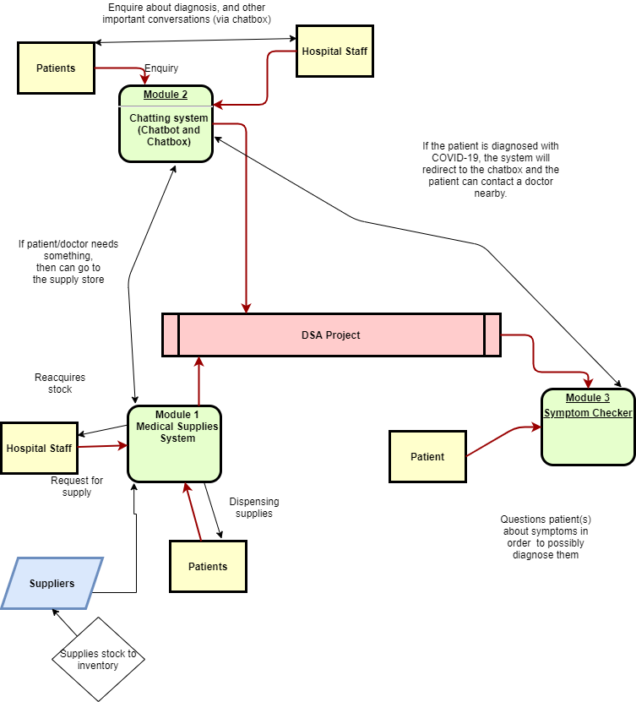

**MODULES IN THE SYSTEM:**

There are 3 main modules that , for now, makes up our project.

Module 1: Medical Supply System

The supplier has added some supplies to the inventory of the system.

Input:

Can be from patient or hospital staff.

Patient: Requesting Medicines

Hospital Staff: Requesting Equipment and Supplies

Output:

Dispensing medicines to patients and resupplying the Hospital Staff with equipment and supplies.

Module 2:Chatting Services(Chatbot/Chatbox)

Input:

Patient: Enquires with Doctor/Bot with the Diagnostic info from symptom checker or for consultation.

Output:

The Doctor/Bot responds according to the enquiry of the patient and can initiate medical services if required.

Module 3: Symptom Checker

Input:

Patient answers a few questions provided to diagnose the patient.

Output:

The system or program determines/predicts whether the patient is COVID positive or not.